**A Mechanical Model of the Frog Ankle as a Biological Cam**

Louis J Dankovich IV1, Benjamin Perlman2, Sarah Bergbreiter1, Emanuel Azizi 2

*1 Department of Mechanical Engineering, University of Maryland, College Park, MD*

*2 Department of Ecology and Evolutionary Biology,* *University of California, Irvine, CA*

Frogs are some of the more effective vertebrate jumpers. They can produce ground reaction forces (GRF) of 4 times their body mass and travel up to 30 body lengths[1]. How they accomplish this is still debated among biologists; it is generally agreed that the mechanism involves a mineral knob in the frogs’ Achilles tendon [2]. Of the two prevailing hypotheses, one holds that this knob acts as a biological latch and allows the tendon to store energy. The other posits that the knob allows the ankle joint to act as a biological cam by increasing joint radius (Rankle). In order to test the biological cam hypothesis, a simplified model of a frogs’ ankle joint as a single DOF hinge was constructed using typical limb length and joint radius values. This model is shown in Figure 1. A cable, with a bead threaded onto it and glued in place, was used as a stand in for the Achilles tendon and its’ mineral knob. A pulley mounted on a servomotor was used to simulate muscle contractions by winding the cable. Set screws were used to hold the cable in place on the pulley and the tarsus, and allowing for the length of cable (Lbead­) between bead and insertion point to be adjusted. The effect of the bead on Rankle can be seen in Figure 2.

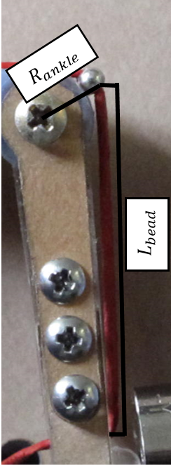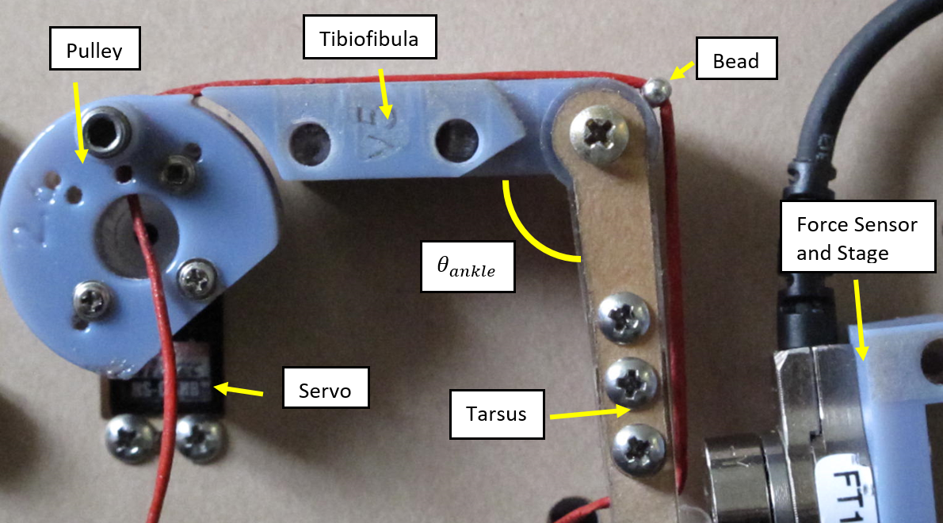

Figure 1: Simplified Frog Leg Model

Figure 2: Variable Knee Radius

The blocked GRF of the assembly was tested at ankle joint angles ( $θ_{ankle})$ ranging from 350 to 1650. At each $θ_{ankle}$ and Lbead combination, three trials were run. The average force from each set of trials was used to create force profiles over the joints range of motion and plotted in Figure 3. As predicted, the GRF for all $θ_{ankle}$ increased significantly over control trials utilizing a cable with no bead due to the increase of Rankle. It was also observed that for larger values of Lbead, peak forces were generated at a smaller $θ_{ankle}$. The force profile produced by a frogs’ ankle when jumping is a good match for the plot of the 44 mm Lbead. The data fits the hypothesis that the frogs’ ankle functions as a biological cam, and this mechanism could be used as a novel means of adjusting force profiles in jumping robots.

Figure 3: Force Profiles as a function of Lbead

**References**

[1] E. Kuan Moo, D. R. Peterson, T. R. Leonard, M. Kaya, and W. Herzog, “In vivo muscle force and muscle power during near-maximal frog jumps.”

[2] H. C. Astley and T. J. Roberts, “The mechanics of elastic loading and recoil in anuran jumping,” *J. Exp. Biol.*, vol. 217, no. 24, 2014.